张越宇

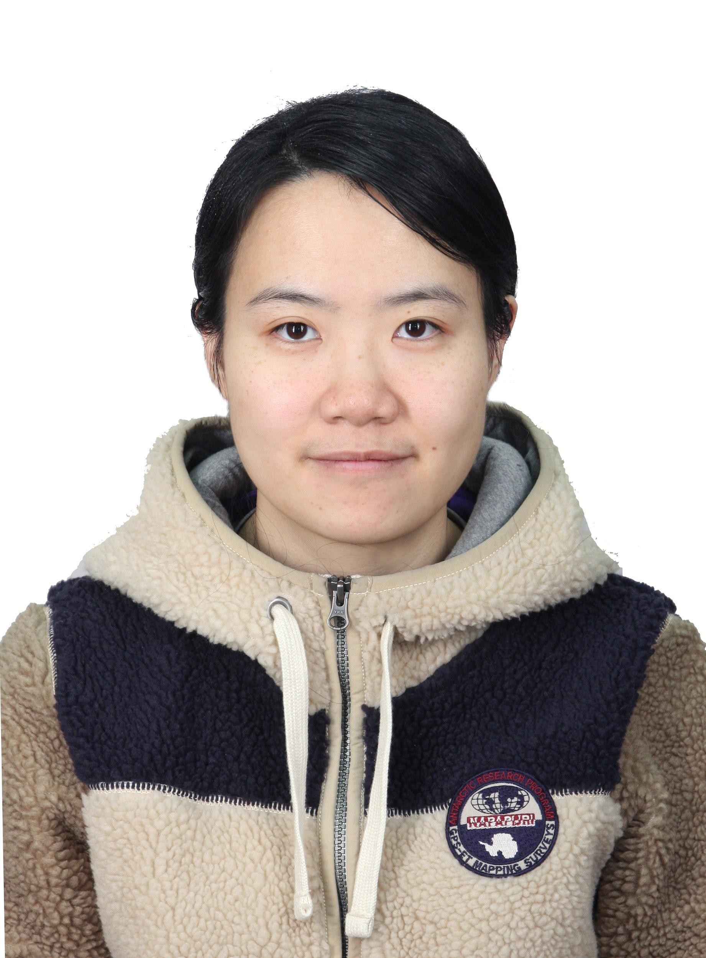
基本信息
性别: 女
出生年月: 1989.10
联系电话: (+86) 18918037139
电子邮箱: yueyu.zhang@foxmail.com
户籍地址: 上海市徐汇区淮海中路1610弄8号

教育
- 2012.09 - 2017.07 复旦大学, 上海, 中国 研究课题: 逆向材料设计
物理学博士 研究领域: 计算凝聚态物理 导师: 龚新高院士
- 2008.09 – 2012.07 华东理工大学, 上海, 中国
物理学士 毕业设计: 硅纳米线的结构预测 导师: 钟菊花教授
(校优秀毕业论文)

工作经历
- 2021.04 至今 华东理工大学 科研助理
- 2020.01 - 2021.03 博士后 帝国理工 合作导师: Clotilde Cucinotta 博士
- 2017.09 - 2019.12 博士后 苏黎世联邦理工 合作导师: Michele Parrinello 院士

主要科研项目
- 2012.09 - 2017.07 开发软件包 IM2ODE
  - 提出将多目标全局优化用于功能性材料预测
  - 开发具有自主知识产权的‘IM²ODE’软件包, 并在开源平台公开发布: https://github.com/YueyuZhang/IM2ODE
  - 该软件包可用于预测特定带隙的半导体材料和超硬材料。该软件包已被用于纯碳材料和二氧化钛太阳能吸收材料的预测。该软件包还被应用于预测具有合适带隙的碳材料和二氧化钛。该软件包还能被用于预测二维材料，包括硫化硅和层状硅材料。
- 2012.09 –2017.07 光电化学性能模拟 （与复旦大学先进材料实验室合作）
  - 参与研究如何增强二氧化钛体系光吸收的机理, 包括二氧化钛和其他纳米结构之间的电荷转移等, 研究的体系涵盖小于5纳米铅笔石墨量子点, C₃N₄量子点, 以及钨掺杂的二氧化钛纳米线阵列.（文章发表在Nature Chemistry，所有作者中计算的第一顺位）
  - 预言了聚酰亚胺可用于水系锂点的阳极材料.
- 2014.09 –2017.07 三步法计算带阶
  - 参与开发了三步法用于半导体异质结的带阶计算.
  - 应用三步法计算金红石和锐钛矿的氧化钛只加的带阶.
- 2017.09 – 2018.09 结晶过程的增强采样
  - 改进了各向同性结晶的协同变量.
- 2017.09 – 2019.12 开发基于深度神经网络的增强采样
  - 训练了深度神经网络用于增强采样.
  - 采用神经网络增强采样研究蛋白质折叠.
- 2020.01 – 2021.03 非平衡态格林函数方法用于输运计算
  - 写smeagol软件和cp2k软件的接口，使cp2k能做非平衡态格林函数的计算

技能
基于密度泛函的电子结构性质计算
- 全局优化算法
- 基于增强采样的
- 非常强的编程能力
- 善于沟通与协作

教学经历
- 2012.09 – 2013.01 大学物理 助教 复旦大学
- 2013.02 – 2013.06 计算物理 助教 复旦大学
- 2020.09 - 2020.12 三年级计算实验 助教 帝国理工

软件著作

- 基于多目标全局优化算法进行逆向材料设计软件V1.0，登记号：2017SR179010 （第二完成人，所有完成人：龚新高，张越宇，向红军）

奖项
- 2020升起的新星提名(Recipient of Rising Star Finalist 2020 from Computational Materials Science)， 计算材料科学杂志社，爱斯维尔, 2020
- 特等奖, ‘2019最具影响力文章’ 中国物理通讯，中国物理学会, 2019
- 优秀毕业生，复旦大学, 2017
- 陶氏化学奖(Dow Chemical awards for sustainable development)，可持续发展方向, 2017
- 最佳海报奖, 第6届国际量子能源会议, 2016
- 2011协同创新中心一等奖学金, 2016
- 博士生国家奖学金, 2015（华东理工大学）
- 复旦大学二等奖学金, 2013
- 华东理工大学优秀毕业生奖, 2012
- 数学建模竞赛特等奖提名, 2011 & 2012
- 国家奖学金，2010（华东理工大学）
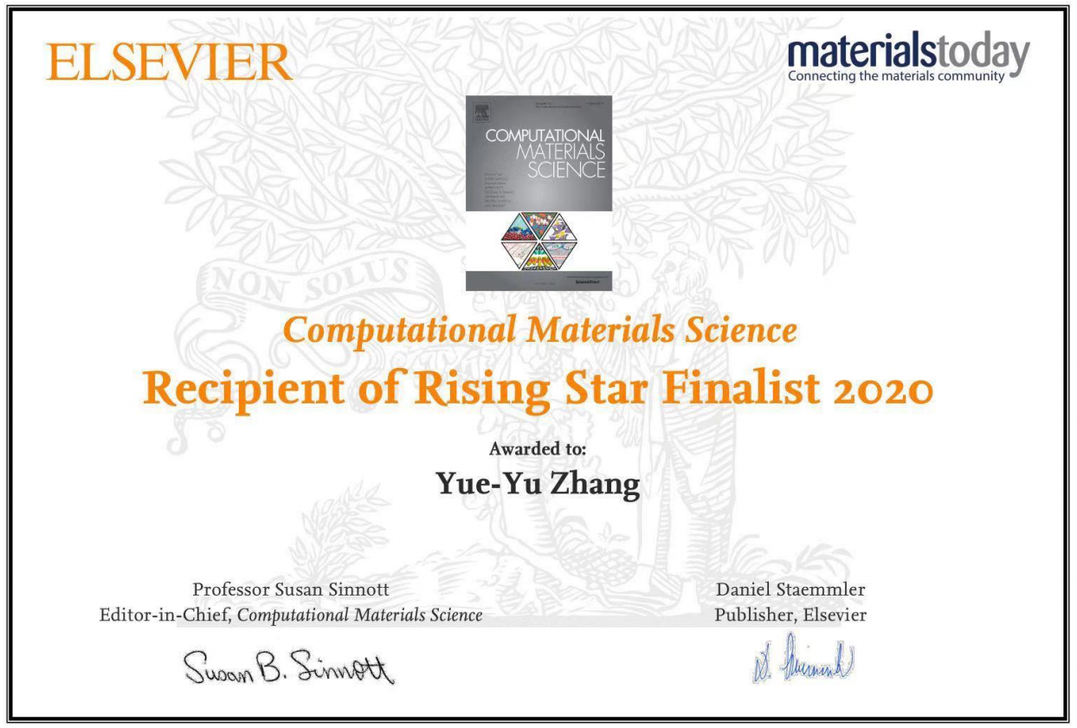

口头报告
- Feb. 6 - 9, 2019: 国际高等学校(Scuola Internazionale Superiore di Studi Avanzati), 的里雅斯特, 意大利
讲座: 改进协同变量: 结晶( Improving Collective Variables: The Case of Crystallization)
- Jul. 15 – 18, 2016: 第19届中国凝聚态与统计物理会议, 湘潭, 中国
报告: 基于多目标优化的逆向材料设计及其应用
- Sep. 11 – 14, 2014: 中国物理学秋季会议, 哈尔滨, 中国
报告: 多目标优化的逆向材料设计方法

文章
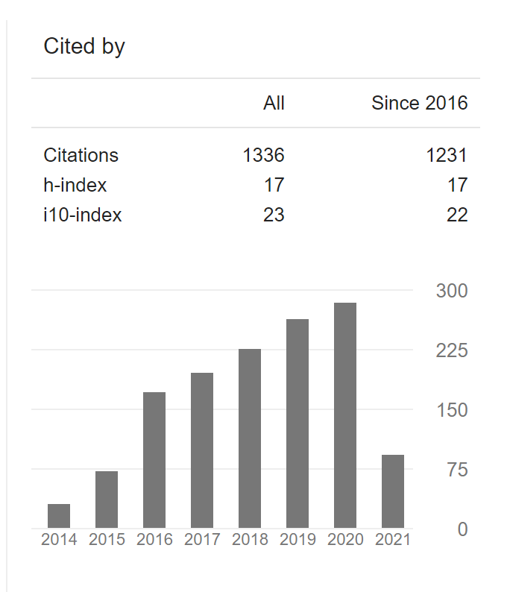
Google scholar 被引1300多次，H因子17
第一作者
- Zhang YY, Gao WG, Chen SY, Xiang HJ, Gong XG*, "Inverse design of materials by multi-objective differential evolution", Comput. Mater. Sci., 2015, 98, 51-55.
- Zhang YY, Chen SY, Xiang HJ, Gong XG*, "Hybrid Crystalline sp²-sp³ Carbon as a High-Efficiency Solar Cell", Carbon, 2016, 109, 246-252.
- Zhang YY, Lang L, Gu HJ, Chen SY, Liu ZP, Xiang HJ, Gong XG*, "Origin of the type-II band offset between rutile and anatase titanium dioxide: Classical and quantum-mechanical interactions between O ions", Phys. Rev. B, 2017, 95, 155308.
- Zhang YY, Chen S, Xu P, Xiang H, Gong XG, Walsh A, Wei SH, "Intrinsic instability of the hybrid halide perovskite semiconductor CH₃NH₃PbI₃" ,Chinese Physics Letters, 2018, 35 (3), 036104 (被引超过150次)
- Zhang YY, Niu H, Piccini GM, Mendels D, Parrinello M*, "Improving Collective Variables: The Case of Crystallization", J. Chem. Phys. 2019, 150, 094509
共同一作
- Chen HZ, Zhang YY, Gong XG*, Xiang HJ*, "Predicting New TiO₂ Phases with Low Band Gaps by a Multiobjective Global Optimization Approach", J. PHYS. Chem. C, 2014, 118, 2333-2337.
- Tang J, Li J, Zhang YY, Kong B, Yiliguma, Wang Y, Quan YZ, Cheng H, Al-Enizi AM, Gong XG, Zheng GF *, "Mesoporous Fe₂O₃/CdS heterostructures for real-time photoelectrochemical dynamic probing of Cu²⁺", Anal. Chem., 2015, 87, 6703-6708.
- Tang J, Quan YZ, Zhang YY, Jiang M, Al-Enizi AM, Kong B, An TC, Wang WS, Xia LM, Gong XG, Zheng GF *, "Three-dimensional WS² nanosheet networks for H₂O₂ produced for cell signaling", Nanoscale, 2016, 8, 5786-5792.
- Wang YH, Cui XQ, Zhang YY, Zhang LJ, Gong XG*, Zheng GF *, "Achieving high aqueous energy storage via hydrogen generation passivation", Adv. Mater., 2016, 28, 7626-7632.
- He S, Zhang YY, Qiu L, Zhang L, Xie Y, Pan J, Chen P, Wang B, Xu X, Hu Y, Dinh CT, Luna PD, Banis MN, Wang Z, Sham TK, Gong XG, Zhang B*, Peng H* ,Sargent E H*, “Chemical‐to‐electricity carbon: water device”, Adv. Mater., 2018, 30(18), 1707635.
其他作者
- Liu HR, Yang JH, Zhang YY, Chen SY, Walsh A, Xiang HJ, Gong XG*, Wei SH, "Prediction of (TiO₂)x(Cu₂O)y alloys for efficient photoelectrochemical water splitting", Phys. Chem. Chem. Phys., 2013, 15, 1778-1781.
- Li ZL, Li ZM, Cao HY, Yang JH, Shu Q, Zhang YY, Xiang HJ*, Gong XG*, "What are grain boundary structures in graphene?", Nanoscale, 2014, 6, 4309-4315.
- Yang JH*, Zhang YY, Yin WJ, Gong XG, Yakobson BI, Wei SH*, "Two-Dimensional SiS Layers with Promising Electronic and Optoelectronic Properties: Theoretical Prediction", Nano Lett., 2016, 16, 1110-1117.
- Liu CY, Zhang YY, Hou YS, Chen SY, Xiang HJ, Gong XG*, "Self-passivation rule and structure of CdTe Σ3 (112) grain boundaries", Phys. Rev. B, 2016, 93, 205426.
- Lu J, Wei SH*, Zhang YY, Hua DY, Duan XM, "Geometric, electronic and magnetic properties of Au_{n}, Au_{(n−1)}Pt and Au_{(n−2)}Pt₂ (n = 2–9) clusters: A first-principles study", Comput. Theor. Chem., 2016, 157-164.
- Guo ZX*, Zhang YY, Xiang HJ, Gong XG, Oshiyama A, "Structural evolution and optoelectronic applications of multilayer silicene", Phys. Rev. B, 2015, 92, 201413(R).
- Kong B, Tang J, Zhang YY, Jiang T, Gong XG, Peng CX, Wei J, Yang JP, Wang YC, Wang XB, Zheng GF *, Selomulya C*, Zhao DY*, "Incorporation of well-dispersed sub-5-nm graphitic pencil nanodots into ordered mesoporous frameworks", Nature Chem., 2016, 8, 171-178.
- An TC, Tang J, Zhang YY, Quan YZ, Gong XG, Al-Enizi AM, Elzatahry AA, Zhang LJ*, Zheng GF *, "Solar water splitting from graphitic C₃N₄ quantum dot decorated semiconductor nanowires", ACS Appl. Mater. Interfaces, 2016, 8, 12772-12779.
- Kong B, Tang J, Zhang YY, Selomulya C, Gong XG, Liu Y, Zhang W, Yang JP, Wang WS, Sun XT, Wang YF, Zheng GF *, Zhao DY*, "Branched artificial nanofinger arrays by mesoporous interfacial atomic rearrangement", J. Am. Chem. Soc., 2015, 137, 4260-4266.
- Li WJ, Da PM, Zhang YY, Wang YC, Lin X, Gong XG, Zheng GF *, "WO₃ nanoflakes for enhanced photoelectrochemical conversion", ACS Nano, 2014, 8, 11770-11777.
- Tang J, Zhang YY, Kong B, Wang YC, Da PM, Li J, Elzatahry AA, Zhao DY, Gong XG*, Zheng GF *, "Solar-driven photoelectrochemical probing of nanodot/nanowire/cell interface", Nano Lett., 2014, 14, 2702-2708.
- Wang YC, Zhang YY, Tang J, Wu HY, Xu M, Peng Z, Gong XG, Zheng GF *, "Simultaneous etching and doping of TiO₂ nanowire arrays for enhanced photoelectrochemical performance", ACS Nano, 2013, 7, 9375-9383.
- Gu HJ, Zhang YY, Chen SY, Xiang HJ, Gong XG, "Intermediate-phase method for computing the natural band offset between two materials with dissimilar structures", Physical Review B, 2018, 97 (23), 235308
- Lang L, Zhang YY, Xu P, Chen SY, Xiang HJ*, Cong XG*, "Three-step approach for computing band offsets and its application to inorganic ABX₃ halide perovskites", Phys. Rev. B, 2015, 92, 075102.
- Li J, Zhu H-F, Zhang YY, Yuan ZK, Chen S, Gong XG*, "Large carrier-capture rate of antisite in induced by heavy atoms and soft phonon modes", Physical Review B, 2017, 96 (10), 104103
- Bonati L, Zhang YY, Parrinello M*, “Neural networks-based variationally enhanced sampling”, Proc. Natl. Acad. Sci, 2019, 1907975116
- Zhang YL, Zhang YY, Ni JY, Yang JH, Xiang HJ, Gong XG, "Rational Design of Two-Dimensional Magnetic Chromium Borides Based on First-Principles Calculation", Chinese Physics Letters, 2021, 38(2), 027501

